**Monolithic vs Microservices Architecture**

**Monolithic Architecture**

Monolithic architecture is a traditional software design pattern where all components of an application—user interface, business logic, and data access layer—are built as a single, unified unit. It is typically deployed as one executable or a WAR/JAR file and shares a single codebase and database.

In this model, changes to any part of the application require rebuilding and redeploying the entire system. It is easier to develop initially and deploy in smaller teams, making it suitable for simple applications or early-stage startups.

**Example:** A basic online bookstore where the cart, product listing, checkout, and user authentication are all built into a single application using Spring MVC and MySQL.

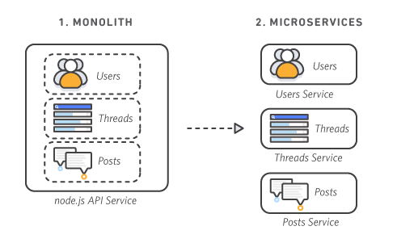

**Microservices Architecture**

Microservices architecture breaks an application into a set of small, independently deployable services. Each service corresponds to a specific business function and communicates with others via APIs or messaging queues. These services are built, deployed, and scaled independently, often using containerization technologies like Docker and orchestration tools like Kubernetes.

This model promotes modularity, autonomy among development teams, and rapid scalability. It aligns well with agile, DevOps, and CI/CD practices.

**Example:** The same online bookstore is restructured into multiple services like Catalog Service, Cart Service, Checkout Service, and User Service—each with its own codebase and data store, possibly written in different programming languages.

**Comparison Table: Monolithic vs Microservices**

| **Feature** | **Monolithic Architecture** | **Microservices Architecture** |
| --- | --- | --- |
| **Design** | Single codebase, unified build | Distributed services, each with independent codebase |
| **Deployment** | Entire app is deployed as one unit | Each service can be deployed independently |
| **Technology Stack** | Typically uses one language/framework | Allows polyglot programming across services |
| **Scalability** | Scale entire application | Scale individual services based on demand |
| **Development Team** | Centralized, tightly coupled team | Decentralized teams aligned by service ownership |
| **Maintenance** | Changes may impact the whole application | Easier to maintain and update services in isolation |
| **Startup Time** | Usually longer due to unified structure | Shorter per service, overall faster restarts |
| **Failure Impact** | One failure can affect the whole app | Failures are isolated to specific services |
| **Testing** | Easier to perform end-to-end tests | More complex due to distributed architecture |
| **Examples** | Early versions of WordPress, e-commerce sites | Netflix, Amazon, Uber |

**Advantages and Disadvantages**

**Monolithic Architecture**

**Advantages:**

* Easier initial development and debugging
* Simpler deployment and testing
* Less DevOps complexity required

**Disadvantages:**

* Difficult to scale specific modules
* Tightly coupled code makes maintenance harder over time
* Any small change requires full redeployment
* Not suitable for large or complex teams

**Microservices Architecture**

**Advantages:**

* Modular and scalable
* Faster deployments with CI/CD pipelines
* Teams can work independently and in parallel
* Easier to adopt new technologies incrementally

**Disadvantages:**

* Complex service coordination and communication
* Requires strong monitoring and observability tools
* Network latency and data consistency issues
* Demands high DevOps maturity and cloud readiness

**Real-World Case Study: Netflix**

**Then (Monolith):**

Netflix initially had a monolithic application running in a single data center. As the user base grew globally, it experienced frequent downtimes, poor scalability, and slow feature releases.

**Now (Microservices):**

Netflix transitioned to a microservices architecture with hundreds of services (e.g., user profile, billing, recommendations). Each service runs in its own container, monitored using tools like Hystrix and managed via orchestration platforms.

**Impact:**

* Achieved 99.99% availability across global users
* Continuous delivery pipelines support multiple releases per day
* Services can fail gracefully without affecting user experience

**Use Case-Based Scenario**

**Scenario:**  
A university is launching a student portal. Initially, the team opts for a monolithic architecture for speed and ease. As the portal grows and integrates services like attendance, fee payment, learning management, and mobile apps, the monolith becomes difficult to manage.

**Decision Point:**

The team decides to adopt microservices, breaking the portal into smaller services. Now, the LMS team can work independently from the finance team, and the system scales better during admission season.

**Conclusion**

Choosing between monolithic and microservices architecture depends on factors like project complexity, team size, long-term scalability goals, and DevOps capabilities. Monolithic is simpler and better for small applications or early-stage projects, while microservices are ideal for large, dynamic, and distributed systems demanding flexibility and resilience. Many organizations start monolithic and gradually migrate to microservices as they scale.